“Automatically Generating Medical Reports from ECG Signals using Deep Learning”
https://arxiv.org/html/2412.04067v1, Banerjee et al.
This study introduces an innovative approach to text generation designed for ECG analysis, validated on the publicly available PTB-XL dataset [6]. In addition to achieving state-of-the-art performance, a key contribution of this work is the establishment of a reproducible benchmark for future studies, as our work is, to the best of our knowledge, first of its kind to be tested on the official test subset of the PTB-XL dataset, ensuring both transparency and comparability.

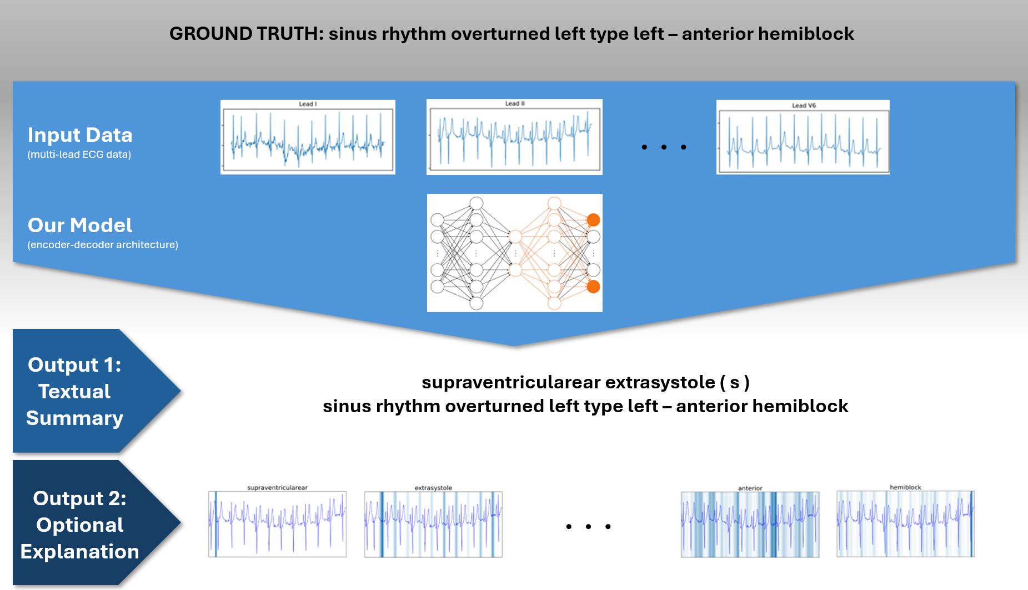

The method introduced in this study employs an encoder-decoder architecture, utilizing a ResNet-based encoder [7] paired with either an LSTM [8] or Transformer [9] decoder.

A key takeaway from these reviews is that the majority of existing ECG analysis methods focus primarily on the classification of ECG episodes, such as identifying atrial fibrillation (AF) or other abnormal heart rhythms. In contrast, the field of automated report generation for ECG data remains largely unexplored

Our LSTM-based model architecture: The ECG signal is input into the 1D ResNet34, producing 512 channels, each of a user-defined size $x$ ($x=240$ in our best-performing model). An attention network aggregates the $x$ temporal data points into a single value per channel, forming a 512-length embedding vector. The vector and current network state are used for predicting the next word

Encoder Pre-Training: In one configuration, we pre-trained the encoder using rhythm class labels as a preliminary task to strengthen ECG embeddings before fine-tuning on free-text reports

Splits for training:

PTB-XL: We tested two splitting approaches for this dataset. The first approach used the official splits provided by PhysioNet, which maintain patient exclusivity across splits and mitigate data leakage risks. These splits allocate 80% of data for training, 10% for validation, and 10% for testing, as further detailed in [6]

Evaluation:
BLEU, ROUGE and METEOR
MRScore: https://arxiv.org/abs/2404.17778

New lectures!
https://aclanthology.org/2023.findings-eacl.33/
Additionally, Qiu et al. introduced an Optimal Transport (OT)-based objective complementing the standard cross-entropy loss, to enhance alignment between ECG embeddings and language embeddings!!

M. G. Bartels, I. Najdenkoska, R. R. van de Leur, A. Sammani, K. Taha, D. M. Knigge, P. A. Doevendans, M. Worring, and R. van Es, “Learning to automatically generate accurate ecg captions,” in International Conference on Medical Imaging with Deep Learning. PMLR, 2022, pp. 86–102.

Personal Conclusion: A 2nd approach to the problem is instead of fine-tuning LLMs, we could recreate our own model: a transformer encoder (combined input of ECG embeddings and tokenized report sequences) and LSTM decoder.

Check for abbreviation in reports! (see next page)

Questions to the authors:
Why not using multimodal LLMs? Why choose to recreate a whole infrastructure?
Not good at the time on the beginning of the research but interesting area to look in now

How did you align the distribution of the two embeddings space (the one of the encoder and of the decoder)?
Did not, lack of time

Based on your understanding, do you think it is possible to do longer reports? Have you done any work in that regards?
Yes

Do you personally believe ECG have the potential to capture even more information, as the one in the CMR reports?
What are your thoughts on the evaluation tools (BLEU ROUGE, METEOR)?
METEOR is the best

What about LLMs as a judge / evaluation, such as MRScore? And the Q&A approach (generating questions from the report and trying to answer them with the text generated)?
BERT score was not really helpful (99.9% and no emphasis on key clinical terms)

Advices: start with benchmarks because it is often needed (download online datasets)

Encoder-Decoder in a nutshell
We encode the ECG into a low-dimensional vector using a neural encoder.
A learned linear projection maps this vector into the LLM’s hidden dimension.
The LLM conditions on this vector to predict the next word in the report.
We compute cross-entropy loss between predicted token probabilities and the true report tokens.
Gradients update the ECG encoder and projection so that the ECG embedding becomes maximally useful for generating the correct CMR text.

Replaced Term | Unified Form
@ | at
+, & | and
pac, pacs, sve, sves, apc, apcs | premature atrial contraction
pvc, pvcs, vpc, vpcs, ves | premature ventricular contraction
ectopic, ectopics, ectopy | premature contraction
brady | bradycardia
sb | sinus bradycardia
tachy, tachycardia | tachycardia
st | sinus tachycardia
svt | supraventricular tachycardia
nsvt | nonsustained ventricular tachycardia
sr | sinus rhythm
nsr | normal sinus rhythm
af, afib, a-fib | atrial fibrillation
afl, a-flutter, aflutter | atrial flutter
cw | continuous wave
rvr | rapid ventricular rate
ppm | permanent pacemaker
bpm | beats per minute
pat, pt | patient
bts | beats
wo, w/o | without
w, w/ | with
hr | heart rate
avb | atrioventricular block

 | description
NDT | non-diagnostic T abnormalities
NST_ | non-specific ST changes
DIG | digitalis-effect
LNGQT | long QT-interval
NORM | normal ECG
IMI | inferior myocardial infarction
ASMI | anteroseptal myocardial infarction
LVH | left ventricular hypertrophy
LAFB | left anterior fascicular block
ISC_ | non-specific ischemic
IRBBB | incomplete right bundle branch block
1AVB | first degree AV block
IVCD | non-specific intraventricular conduction disturbance (block)
ISCAL | ischemic in anterolateral leads
CRBBB | complete right bundle branch block
CLBBB | complete left bundle branch block
ILMI | inferolateral myocardial infarction
LAO/LAE | left atrial overload/enlargement
AMI | anterior myocardial infarction
ALMI | anterolateral myocardial infarction
ISCIN | ischemic in inferior leads
INJAS | subendocardial injury in anteroseptal leads
LMI | lateral myocardial infarction
ISCIL | ischemic in inferolateral leads
LPFB | left posterior fascicular block
ISCAS | ischemic in anteroseptal leads
INJAL | subendocardial injury in anterolateral leads
ISCLA | ischemic in lateral leads
RVH | right ventricular hypertrophy
ANEUR | ST-T changes compatible with ventricular aneurysm
RAO/RAE | right atrial overload/enlargement
EL | electrolytic disturbance or drug (former EDIS)
WPW | Wolf-Parkinson-White syndrome
ILBBB | incomplete left bundle branch block
IPLMI | inferoposterolateral myocardial infarction
ISCAN | ischemic in anterior leads
IPMI | inferoposterior myocardial infarction
SEHYP | septal hypertrophy
INJIN | subendocardial injury in inferior leads
INJLA | subendocardial injury in lateral leads
PMI | posterior myocardial infarction
3AVB | third degree AV block
INJIL | subendocardial injury in inferolateral leads
2AVB | second degree AV block
ABQRS | abnormal QRS
PVC | ventricular premature complex
STD_ | non-specific ST depression
VCLVH | voltage criteria (QRS) for left ventricular hypertrophy
QWAVE | Q waves present
LOWT | low amplitude T-waves
NT_ | non-specific T-wave changes
PAC | atrial premature complex
LPR | prolonged PR interval
INVT | inverted T-waves
LVOLT | low QRS voltages in the frontal and horizontal leads
HVOLT | high QRS voltage
TAB_ | T-wave abnormality
STE_ | non-specific ST elevation
PRC(S) | premature complex(es)
SR | sinus rhythm
AFIB | atrial fibrillation
STACH | sinus tachycardia
SARRH | sinus arrhythmia
SBRAD | sinus bradycardia
PACE | normal functioning artificial pacemaker
SVARR | supraventricular arrhythmia
BIGU | bigeminal pattern (unknown origin, SV or Ventricular)
AFLT | atrial flutter
SVTAC | supraventricular tachycardia
PSVT | paroxysmal supraventricular tachycardia
TRIGU | trigeminal pattern (unknown origin, SV or Ventricular)

